- What are iRules in F5 LTM?
iRules are built using a TCL-based scripting language allowing arbitrary manipulation of traffic flowing through the BIG-IP, including real-time modification of defined data.
- What is iControl?
iControl is a Web services-enabled open API providing granular control over the configuration and management of F5's application delivery platform, BIG-IP
- What is the default LTM MGMT port IP Address?
By default, the management interface of the VE has an IP address of 192.168.1.245/24. if you try to convert 245 to hexadecimal then you will get F5, as shown below. Very geeky in my opinion!
- What is ConfigSync?
Configuration synchronization (also known as config sync ) is the operation that the BIG-IP system performs to propagate BIG-IP configuration changes to all devices in a device group.
Automatic and manual sync:
You can configure the BIG-IP system to synchronization configuration data automatically, or you can manually initiate synchronization
- How is a member different than a node?
A node is a logical object on the BIG-IP® the BIG-IP system. System that identifies the IP address of a physical resource on the network. You can explicitly create a node, or you can instruct the BIG-IP system to automatically create one when you add a pool member to a load balancing pool.
The difference between a node and a pool member is that a node is designated by the device’s IP address only (10.10.10.10), while designation of a pool member includes an IP address and a service (such as 10.10.10:80).
- What is OneConnect and its benefit?
OneConnect™ is a feature of the BIG-IP LTM system that improves web application performance and decreases server load by reducing the concurrent connections and connection rate on back-end servers. OneConnect reuses TCP connections to each server for multiple clients. After the BIG-IP LTM has sent a request and received a complete response, these connections are put in a Connection Reuse Pool. When new clients create new TCP connections to the BIG-IP LTM, instead of creating new TCP connections to the servers, the BIG-IP LTM may pick existing connections from the Connection Reuse Pool.
- What is a load balancing pool?
A load balancing pool is a logical set of devices, such as web servers, that you group together to receive and process traffic. Instead of sending client traffic to the destination IP address specified in the client request, Local Traffic Manager sends the request to any of the servers that are members of that pool. This helps to efficiently distribute the load on your server resources. A pool member is a logical object that represents a physical node (server), on the network. You then associate the pool with a virtual server on the BIG-IP system. Once you have assigned a pool to a virtual server, Local Traffic Manager (LTM) directs traffic coming into the virtual server to a member of that pool. An individual pool member can belong to one or multiple pools, depending on how you want to manage your network traffic.
Feature: you can configure Local Traffic Manager (LTM) to perform a number of different operations for a pool. For example, you can:
- Associate health monitors with pools and pool members
- Enable or disable SNAT connections
- Rebind a connection to a different pool member if the originally-targeted pool member becomes unavailable
- Specify a load balancing algorithm for a pool
- Set the Quality of Service or Type of Service level within a packet
- Assign pool members to priority groups within a pool

- What is meaning of session persistence and why is it required?
- Session persistence refers to directing a client’s requests to the same backend web or application server for the duration of a “session” or the time it takes to complete a task or transaction.
- High-traffic websites must support hundreds of thousands, if not millions, of users in a fast, reliable manner. IT organizations support these large volumes by grouping servers into what is often called a server farm. A load balancer sits in front of the server group and directs traffic to individual servers in a way that maximizes efficiency.
- If a user browses your website for five minutes, she probably fetches information from multiple backend servers. Not accessing the same server every time can cause problems if the web browser or backend server tries to improve the web experience by storing information that enables the user’s next action to occur more quickly. In this case, it is important – not to say imperative – that all of the user’s requests are sent to the same server.
- In other instances, a user might engage in a transaction that requires multiple steps such as filling out a form, purchasing a product, or upgrading his account. As the client and server exchange data, they need to store state information about the session (referred to as context) for the transaction to proceed smoothly. In this case, session persistence makes it much easier for transactions to complete successfully.
- What is a profile?
--> Profiles are the collection of settings that define traffic behavior or traffic policy applied on a virtual server.
--> In simple terms, a profile is an object in BIG IP LTM that controls the behavior of a particular type of network traffic such as HTTP.
--> By using profiles in F5 LTM, we can perform following tasks,
1) Change the traffic behavior of some types of network traffic.
2) Improves performance and throughput in the network.
3) We can implement persistence and SSL offloading by using profiles.
4) Implement Authentication on Virtual Server.
--> It is possible to apply multiple profiles to the single virtual server.
--> By default, BIG IP LTM comes with some set of profiles which we can apply to virtual servers.
--> This profiles are called default profiles.
--> It is also possible to create custom profiles in BIG IP LTM.
--> A profile can be associated to a virtual server at the time of the creation of virtual server or later on.
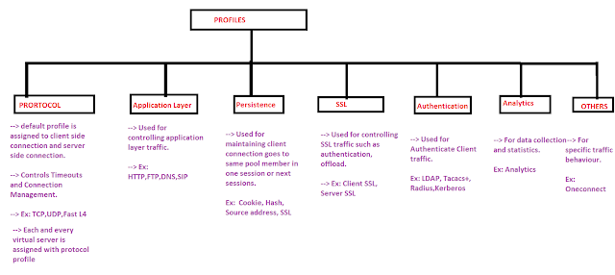
1) Protocol Profile:
--> This is the default Profile.
--> Each and every Virtual Server need to configure with Protocol Profile.
--> Protocol Profile defines connection timeouts and other parameters.
--> Once you select Protocol Profile, F5 BIG IP System automatically assigns client side and server side protocol
based upon the protocol profile chosen.
EX: TCP, UDP, TCP LAN Optimized, TCP Mobile Optimized, TCP WAN Optimized, Fast L4, FAST HTTP
2) Application Profile
--> Application Profile defines how to manipulate traffic at Application Layer.
--> for example if you want to manipulate HTTP traffic or enable compression you need HTTP Profile to be
Configured on Virtual Server. Ex: HTTP, HTTPS, FTP, DNS, SIP, RADIUS, DIAMETER
3) SSL Profile
--> SSL Profile is used to decrypt/encrypt SSL traffic on the Virtual Server.
--> SSL Profile can be of two types:
1) Client SSL Profile: Used to decrypt/encrypt client side traffic
2) Server SSL Profile: Used to decrypt/encrypt Server Side traffic.
4) Persistence Profile:
--> Persistence Profile is used to redirect the client traffic to the same pool member during the session.
--> Persistence Profile can be of following types:
1) Source Address 2) Cookie 3) SSL 4) Hash 5) Microsoft RDP 6) Destination Address 7) SIP
8) Universal 9) SPDY 10) RTSP 11) XML

5) Authentication Profiles
--> Authentication Profile is used to authenticate client/server traffic on Virtual Server.
--> Authentication Profile can be of following types:
1)LDAP 2) RADIUS 3) TACACS 4) KERBEROS 5) LDAPS 6) OCSP 7) XMP

6) OneConnect Profile:
--> OneConnect Profile provides faster performance by reusing server-side connections.

7) Analytic Profile
--> Analytic Profile is used to collect statistical information related to the virtual server.

--> Each and every profile working on a given layer of the OSI model is dependent upon the lower layers.
--> In simple terms, if a profile is working on Application layer is dependent on the transport layer.
--> Every virtual server have a layer 4 profile assigned to it.
--> Profiles working on same OSI Layer cannot be assigned to one Virtual Server.
--> It is not possible to apply both TCP and UDP profiles to a virtual server as well as FTP and HTTP profile also
--> All the default profiles are stored in config/profiles.base.conf file in F5 LTM and it is not recommended to delete the file.
--> Each and every custom profile created on F5 LTM must be associated with Parent Profile.
--> The Parent Profile can be a custom profile or default profile.
--> Whatever the changes you make on parent profile automatically inherited to child profile.
--> If you want to delete any custom profile make sure that it is not a parent profile to any child profile.

- What is RAM cache?
RAM Cache is a cache of HTTP objects stored in the BIG-IP systems. Random access memory (RAM) for reuse by subsequent connections to reduce the amount of traffic load on back-end servers.

- What type items are cached and not cached by RAM feature?
Cacheable content
The RAM Cache feature complies with the cache specifications described in RFC 2616. You can configure the RAM Cache feature to cache the following content types:
- 200, 203, 206, 300, 301, and 410 responses
- Responses to GET requests
- Other HTTP methods for URIs specified for inclusion in cached content, or specified in an iRule
- Content based on the User-Agent and Accept-Encoding values. The RAM cache feature holds different content for Vary headers.
The default RAM cache configuration caches only responses to HTTP GET requests. However, you can use the RAM cache to cache other methods, including non-HTTP methods. To do this, you can specify a URI in the URI Include or Pin List within an HTTP profile, or write an iRule.
Non-cacheable content
The RAM cache feature does not cache the following items:
- Private data specified by cache control headers
- HEAD, PUT, DELETE, TRACE, and CONNECT methods, by default
- What type of lists are considered in URIL Lists?
- Difference between Node and Pool member?
The difference between a node and a pool member is that a node is designated by the device’s IP address only (10.10.10.10), while designation of a pool member includes an IP address and a service (such as 10.10.10:80).
- What are Virtual Servers?
- A virtual server is a traffic-management object on the BIG-IP system that is represented by an IP address and a service. Clients on an external network can send application traffic to a virtual server, which then directs the traffic according to your configuration instructions. A primary purpose of a virtual server is to load balance traffic across a pool of servers on an internal network. Virtual servers increase the availability of resources for processing client requests.
- Not only do virtual servers distribute traffic across multiple servers, they also treat varying types of traffic differently, depending on your traffic-management needs. For example, a virtual server can enable compression on HTTP request data as it passes through the BIG-IP system, or decrypt and re-encrypt SSL connections and verify SSL certificates. For each type of traffic, such as TCP, UDP, HTTP, SSL, SIP, and FTP, a virtual server can apply an entire group of settings, to affect the way that Local Traffic Manager manages that traffic type.
- When you create a virtual server, you specify the pool or pools that you want to serve as the destination for any traffic coming from that virtual server. You also configure its general properties, some configuration options, and other resources you want to assign to it, such as iRules or session persistence types.

Types of virtual servers
- There are several different types of virtual servers that you can create.
Table 1. Types of virtual servers
Type | Description
Standard | A Standard virtual server (also known as a load balancing virtual server) directs client traffic to a load balancing pool and is the most basic type of virtual server. When you first create the virtual server, you assign an existing default pool to it. From then on, the virtual server automatically directs traffic to that default pool.
Forwarding (Layer 2) | You can set up a Forwarding (Layer 2) virtual server to share the same IP address as a node in an associated VLAN. To do this, you must perform some additional configuration tasks. These tasks consist of: creating a VLAN group that includes the VLAN in which the node resides, assigning a self-IP address to the VLAN group, and disabling the virtual server on the relevant VLAN.
Forwarding (IP) | A Forwarding (IP) virtual server is just like other virtual servers, except that a forwarding virtual server has no pool members to load balance. The virtual server simply forwards the packet directly to the destination IP address specified in the client request. When you use a forwarding virtual server to direct a request to its originally-specified destination IP address, Local Traffic Manager adds, tracks, and reaps these connections just as with other virtual servers. You can also view statistics for a forwarding virtual servers.
Performance (HTTP) | A Performance (HTTP) virtual server is a virtual server with which you associate a Fast HTTP profile. Together, the virtual server and profile increase the speed at which the virtual server processes HTTP requests.
Performance (Layer 4) | A Performance (Layer 4) virtual server is a virtual server with which you associate a Fast L4 profile. Together, the virtual server and profile increase the speed at which the virtual server processes Layer 4 requests.
Stateless | A stateless virtual server prevents the BIG-IP system from putting connections into the connection table for wildcard and forwarding destination IP addresses. When creating a stateless virtual server, you cannot configure SNAT automap, iRules, or port translation, and you must configure a default load balancing pool. Note that this type of virtual server applies to UDP traffic only.
Reject | A Reject virtual server specifies that the BIG-IP system rejects any traffic destined for the virtual server IP address.
DHCP Relay | A DHCP Relay virtual server relays Dynamic Host Control Protocol (DHCP) messages between clients and servers residing on different IP networks. Known as a DHCP relay agent, a BIG-IP system with a DHCP Relay type of virtual server listens for DHCP client messages being broadcast on the subnet and then relays those messages to the DHCP server. The DHCP server then uses the BIG-IP system to send the responses back to the DHCP client. Configuring a DHCP Relay virtual server on the BIG-IP system relieves you of the tasks of installing and running a separate DHCP server on each subnet.
Internal | An internal virtual server is one that can send traffic to an intermediary server for specialized processing before the standard virtual server sends the traffic to its final destination. For example, if you want the BIG-IP system to perform content adaptation on HTTP requests or responses, you can create an internal virtual server that load balances those requests or responses to a pool of ICAP servers before sending the traffic back to the standard virtual server.

- What is meant by Pool?
A pool is a logical set of devices, such as web servers, that you group together to receive and process traffic. Instead of sending client traffic to the destination IP address specified in the client request, the BIG-IP® system sends the request to any of the nodes that are members of that pool.
Three types of pools on the system: server pools, gateway pools, and clone pools
A server pool is a pool containing one or more server nodes that process application traffic. The most common type of server pool contains web servers.
A gateway pool is a pool of routers
You use a clone pool when you want to configure the BIG-IP system to send traffic to a pool of intrusion detection systems (IDSs).

- What is meant by member?
A pool member is a logical object that represents a physical node (server) plus service, on the network.
- What is meant by Priority-based member activation?
Priority-based member activation is a feature that allows you to categorize pool members into priority groups, so that pool members in higher priority groups accept traffic before pool members in lower priority groups. The priority-based member activation feature has two configuration settings: you specify the minimum number of members that must remain available in each priority group in order for traffic to remain confined to that group. The allowed value for this setting ranges from 0 to 65535. Setting this value to 0 disables the feature. You also specify a priority group for each member when you add that member to the pool. Retaining the default priority group value of 0 for a pool member means that the pool member is in the lowest priority group and only receives traffic when all pool members in higher priority groups are unavailable. If the number of available members assigned to the highest priority group drops below the number that you specify, the BIG-IP system distributes traffic to the next highest priority group, and so on.
For example, this configuration has three priority groups, 3, 2, and 1, with the priority group activation value (shown here as min active members) set to 2.
pool my_pool { lb_mode fastest min active members 2 member 10.12.10.7:80 priority 3 member 10.12.10.8:80 priority 3 member 10.12.10.9:80 priority 3 member 10.12.10.4:80 priority 2 member 10.12.10.5:80 priority 2 member 10.12.10.6:80 priority 2 member 10.12.10.1:80 priority 1 member 10.12.10.2:80 priority 1 member 10.12.10.3:80 priority 1 }
Connections are first distributed to all pool members with priority 3 (the highest priority group). If fewer than two priority 3 members are available, traffic is directed to the priority 2 members as well. If both the priority 3 group and the priority 2 group have fewer than two members available, traffic is directed to the priority 1 group. The BIG-IP system continuously monitors the priority groups, and whenever a higher priority group once again has the minimum number of available members, the BIG-IP system limits traffic to that group.

- What is TMM and its functionality?
The Traffic Management Microkernel (TMM) processes all load-balanced traffic on the BIG-IP system. TMM runs as a real-time user process within the BIG-IP operating system (TMOS). CPU and memory resources are explicitly provisioned in the BIG-IP configuration.
- What is key difference between LTM and GTM?

Some of the Key differences of the GTM vs LTM
- The biggest difference between the GTM and LTM, as mentioned earlier, is traffic doesn’t actually flow through the GTM to your servers.
- The GTM is an intelligent name resolver, intelligently resolving names to IP addresses.
- Once the GTM provides you with an IP to route to you’re done with the GTM until you ask it to resolve another name for you.
- Similar to a usual DNS server, the GTM does not provide any port information in its resolution.
- The LTM doesn’t do any name resolution and assumes a DNS decision has already been made.
- When traffic is directed to the LTM traffic flows directly through its’ full proxy architecture to the servers its load balancing.
- Since the LTM is a full proxy it’s easy for it to listen on one port but direct traffic to multiple hosts listening on any port specified.

How do the GTM & LTM work together?
The GTM and LTM can work together or they can be totally independent. If your organization owns both modules it’s usually using them together, and that’s where the real power comes in. They do this via a proprietary protocol called iQuery. iQuery, functioning on TCP port 4353, reports VIP availability / performance back to the GTMs. The GTMs can then dynamically resolve VIPs that live on an LTM(s). When a GTM has LTMs as servers in its’ configuration there is no need to monitor the actual VIP(s) with application monitors, as the LTM is doing that & iQuery reports the information back to the GTM. As you can see the GTM & LTM modules are powerful tools in the world of Application Delivery / Load Balancing. Together the GTM & LTM make one mean lean Application Delivery machine.
- What is a tagged Interface?
- You can create a VLAN and assign interfaces to the VLAN as untagged interfaces. When you assign interfaces as untagged interfaces, you cannot associate other VLANs with those interfaces. This limits the interface to accepting traffic only from that VLAN, instead of from multiple VLANs. If you want to give an interface the ability to accept and receive traffic for multiple VLANs, you add the same interface to each VLAN as a tagged interface.
- You can create a VLAN and assign interfaces to the VLAN as single- or double-tagged interfaces. When you assign interfaces as tagged interfaces, you can associate multiple VLANs with those interfaces.
- A VLAN tag is a unique ID number that you assign to a VLAN, to identify the VLAN to which each packet belongs. If you do not explicitly assign a tag to a VLAN, the BIG-IP system assigns a tag automatically. The value of a VLAN tag can be between 1 and 4094. Once you or the BIG-IP system assigns a tag to a VLAN, any message sent from a host in that VLAN includes this VLAN tag as a header in the message.
- Which Command line utility displays real-time statistical information for BIG-IP LTM?

The bigtop tool is a command line utility that displays real-time statistical information for BIG-IP LTM system objects such as virtual servers and nodes. For example, the following items are displayed when using the bigtop utility:
- Current time
- Network activity in bits, bytes, packets, or requests
- Nodes available for virtual servers
- Current state of nodes

The bigtop display
The bigtop display is comprised of the following three sections:
- BIG-IP
- Virtual IP:port
- Node IP:port
- What is cookie persistence?

PERSISTENCE
When an application maintains the session, a persistent session between the client and server must be correctly maintained to ensure the server can continue to process client requests. A typical example is web based shopping carts, this normally requires the user to maintain persistence to a single server during the lifetime of the session.
Persistence is configured via the use of a persistence profile. This alters the load balancing behavior of a virtual server. Upon the initial client connection BigIP tracks and stores session data within a persistence record.

SOURCE ADDRESS PERSISTENCE
Source Address Persistence supports the TCP and UDP protocols and directs traffic to the same server based upon the clients source IP address.
A limitation to source address persistence is when traffic transverses a NAT or proxy device, in which all connections appear to originate from a single IP.

CONFIGURING SOURCE ADDRESS PERSISTENCE
To configure source address persistence:
- Go to 'Local Traffic | Profiles | Persistence | Create'
- Within General Properties add the Name
- Select Source Address Affinity as the Persistence Type
- Click Finished
- Add the Persistence Profile to the Virtual Server, via 'Local Traffic | Virtual Servers | [VS NAME] | Resources | Default Persistence Profile'.

COOKIE PERSISTENCE
Cookie persistence only supports the HTTP protocol. This is because the F5 BigIP is unable to inspect cookies from within an encrypted session. It is also worth noting that if a) the client’s system clock is incorrect or b) cookies are disabled then the cookies may not be sent from the client to BigIP.
The F5 LTM offers 4 main modes of cookie persistence:
Hash mode - Hash mode expects that the server provides the cookie. The system then builds a hash from either part or all of this cookie to build a persistence record.
Insert mode - With Insert Mode the F5 LTM inserts a special cookie in the HTTP Response. These includes the pool named and pool member.
Rewrite mode - Once the web server has created a blank cookie, the F5 LTM rewrites the cookie so that is can be later read as a special cookie and used for persistence.
Passive mode - Passive mode is based upon the web server creating the specially formatted cookie that contains the node IP and port. This cookie is then passively passed through.

CONFIGURING COOKIE PERSISTENCE
To Configure Cookie Persistence follow the steps below:
- Within the Virtual Server ensure that the HTTP profile is configured.
- Within the Virtual Server go to Resources and then select Cookie from the Default Persistence Profile.

OTHER PERSISTENCE METHODS

SSL PERSISTENCE
SSL Persistence uses the SSL Session ID for persistence. Though this has the benefit of providing persistence to SSL sessions that aren't terminated on the F5, as some browsers frequently negotiate the Session ID (due to security reasons) this can lead to short persistence periods. Due to this it is recommended that source IP persistence is defined as backup persistence method.

MATCH ACROSS
Match Across Services - When “Match Across Services” is enabled persistence is matched across all virtual servers that have the same IP address.
Match Across Virtual Servers - When “Match Across Virtual Servers” is enabled persistence is matched across all virtual servers. This is the same as “Match across services” however it allows the client to access different virtual servers and still access the same pool member. This also applies if both virtual servers are using different ports.
Match Across Pools - When “Match Across Pools” is enabled persistence is matched across all pools using any persistence record matching to the client. However, this means that the client could be sent to a pool that is not associated by the virtual.

- What is Self IP address?
-> Self IP Address is the IP Address in F5 which is assigned to VLAN.
--> In Cisco terms, it is similar to SVI where we assign IP Address to VLAN.
--> In F5 LTM, we can assign an IP address to a VLAN or group of VLAN.
--> A static self IP address is an IP address that the BIG-IP system does not share with another BIG-IP system.
--> For each self IP address that you create for a VLAN, the BIG-IP system automatically assigns a media access control (MAC) address.
--> Self IP Address in F5 LTM is used mainly for three purposes,
i) F5 compares destination server IP address with VLAN self IP address to identify which
VLAN it belongs to.
ii) Self IP Address can also be used as the Default gateway for the servers if we configure F5 in
Inline Mode.
iii) Self IP Address is also used to send monitor probes to the group of servers in that VLAN.
--> There are two types of Self IP Addresses used by F5,
i) Static Self IP Address: This is the IP Address is assigned only to one F5 LTM device.
ii) Floating Self IP Address: This is the IP Address is assigned to multiple F5 LTM devices.
- 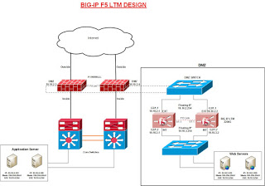

- What is floating self IP address?
--> In Cisco terms, Floating IP Address is similar to Virtual IP Address which is used for Gateway Redundancy.
--> Floating Self IP Address is used for configuration synchronization between F5 LTM.
--> For Every VLAN in F5 LTM, you need to create both Self IP Address and Floating Self IP Address.
--> Each self IP address has a feature known as the port lockdown. Port lockdown is a security feature that allows you to specify particular UDP and TCP protocols and services from which the self IP address can accept traffic.
- What is HTTP chunking?
Chunking is a technique that HTTP servers use to improve responsiveness. Chunking can help you avoid situations where the server needs to obtain dynamic content from an external source and delays sending the response to the client until receiving all of the content so the server can calculate a Content-Length header.
When chunking is enabled, instead of delaying sending packets to the client until all content is available, the server will:
- Send the response in chunks.
- Add a Transfer-Encoding: chunked HTTP header to the chunks.
- Apply markers within the content to indicate the length of each chunk and whether that particular chunk is the last chunk that the server is sending.
- Which are the latest LTM hardware models in market?
i15800 i15600
i11800 i11600
i10800 i10600
i7800 i7600
i5800 i5600
i4800 i4600
i2800 i2600
i11800-DS i11600-DS
i11400-DS i7820-DS
i5820-DF 12250v
10350v/10350v-N/10350v-F 10255v/10250v/10200v-SSL
10055s/10050s/10000s 7255v/7250v/7200v-SSL
7055s/7050s/7000s 5250v/5200v
5050s/5000s 4200v
4000s 2200s 2000s
- What is pipelining?
HTTP pipelining is a feature of HTTP 1.1 that's allows multiple requests to be sent via single connection without waiting for each response. OneConnect does not support Pipelining as each request must be initiated after the response from the previous requests have been received.
- What is Predictive method?
The Predictive method uses the ranking method used by the Observed method, however, with the Predictive method, the system analyzes the trend of the ranking over time, determining whether a server’s performance is currently improving or declining
- What are the capabilities of LTM?
- Which tasks are performed by LTM to offload server of responsibilities?
- What are the authentication modules that can be implemented on F5Big-IP?
- BIG-IP system authentication modules
- Local Traffic Manager authentication modules that you can implement for remote authentication are:
- Lightweight Directory Access Protocol (LDAP)
- Local Traffic Manager can authenticate or authorize network traffic using data stored on a remote LDAP server or a Microsoft Windows Active Directory server. Client credentials are based on basic HTTP authentication (user name and password).
- Remote Authentication Dial-In User Service (RADIUS)
- Local Traffic Manager can authenticate network traffic using data stored on a remote RADIUS server. Client credentials are based on basic HTTP authentication (user name and password).
- TACACS+
- Local Traffic Manager can authenticate network traffic using data stored on a remote TACACS+ server. Client credentials are based on basic HTTP authentication (user name and password).
- SSL client certificate LDAP
- Local Traffic Manager can authorize network traffic using data stored on a remote LDAP server. Client credentials are based on SSL certificates, as well as defined user groups and roles.
- Online Certificate Status Protocol (OCSP)
- Local Traffic Manager can check on the revocation status of a client certificate using data stored on a remote OCSP server. Client credentials are based on SSL certificates.
- Certificate Revocation List Distribution Point (CRLDP)
- Local Traffic Manager can use CRL distribution points to determine revocation status.
- Kerberos Delegation
- Local Traffic Manager can authenticate application traffic when you are using Microsoft Windows Integrated Authentication.
- Important: When you create remote authentication objects and profiles, the BIG-IP system places them into your current administrative partition. Note that the default profile always resides in partition Common.

- What is difference between APM and PAM?
- What are the load balancing methods used in LTM?
https://worldtechit.com/understanding-f5-load-balancing-methods/
- Which all health monitors are available on f5 ltm
A monitor is a test that the LTM can perform on either a node of member. A monitor typically tests for a specific response within a specified time period. BigIP uses the results of this to decide on whether traffic should be sent to the node or pool member.

TYPES OF MONITORING
There 4 main types of monitoring:
- Address Check - IP address (Node)
- Service Check - IP : port
- Content Check - IP : port & check data returned
- Interactive Check - Interactive with servers. Multiple commands and multiple responses.

ADDRESS CHECK
This is the simplest type of check. An example of an address check is ICMP. This is used to ping an IP address and if there is no response within the specified time period the node is marked as down.

SERVICE CHECK
Rather than just checking the IP Service Checks monitors the port. This is achieved by issuing a layer 4 connection to the node. The connection is opened and closed. If connection fails, the member is marked as down and no traffic is distributed to the particular node.

CONTENT CHECK
Content Checks check whether the server is also serving the correct content. Once the TCP connection is opened, a command is sent (such as a HTTP GET) and the response is examined and the connection closed. If the connection fails or the received string is not obtained the member is marked as down and no further connections are sent to the member.
Note: It is important that the receive string is not configured using a string that may be also used with any error pages (such as a 404 page), as this would prevent the monitor from correctly marking the the member as offline.

INTERACTIVE CHECK
Protocols such as FTP require interactive checks as additional commands such as username, password and directory are typically required.
Typically Interactive Checks consist of a TCP connection that is opened, command(s) are then sent, the responses examined and the connection closed.
If any condition fails the member is marked as down and no further connections are sent to the member.
Note : Most interactive checks are external monitors. External monitors external scripts (perl, shell etc) that the LTM calls to perform the required tests (and to aggregate the results).
Below describes the various interactive checks available:
Scripted Monitors - Scripted Monitors use the Expect method/"model" (send/expect) to determine a nodes health. Expect is a UNIX binary that sends a command and then expects are specific response back.
External Monitors - External Monitors are custom shell scripts that can be created to determine the health of a node.
Performance Monitors - As the name suggests Performance monitors deem the nodes health by querying the nodes performance. There are a number of methods in which this can be achieved. These are :
- Dynamic Ratio LoadBalancing - Dynamic Ratio Load-Balancing queries the given agent on either a RealNetwork RealServer, WMI or SNMP based platform to determine a ratio value. This ratio value is then dynamically assigned to the node.
- SNMP DCA - SNMP DCA determines performance via the data collected from the nodes SNMP agent.
- SNMP DCA Base - SNMP DCA determines performance via only the user-data collected from the nodes SNMP agent.
- WMI - WMI determines performance via the data collected from the nodes WMI agent.

MISCELLANEOUS
Inband Passive Monitor - Rather than issue a connection to the server to determine its health, Inband Passive Monitors determine the health of the node by the monitoring of actual traffic being sent to and from the node. The main benefit of this monitor is that it requires little system resource. However as Passive monitors can also be slow to bring pools members back online it is recommended that they are used in conjunction with Active Monitors via the use of the Active Monitor option "Check Until Up".

CREATING CUSTOM MONITORS
Below shows the steps required to create a custom monitor:
- Go to 'Local Traffic | Monitors | Create'.
- Add the Name and select a template from the Type drop down menu.
- Then define the Interval and Timeout.
Note :
Interval - Interval between checks.
Timeout - Defines how long F5 should wait before marking a node/member as down.
Recommended Setting - Timeout = (3 x Interval) + 1 sec.

ASSOCIATING A MONITOR

NODES
To assign a monitor:
- Default: Go to 'Local Traffic | Nodes | Default Monitor' then define the active health monitor.
- Single Node: To set a monitor to one node go to 'Local Traffic | Nodes | Node List' and select the node. Then from the Health Monitor drop down select the monitor.

POOL
To assign a monitor to a pool.
- Go to 'Local Traffic | Pools' and select the pool.
- Within the configuration screen select the Health Monitor.

POOL MEMBER
- Go to 'Traffic | Pools' and select the Pool.
- Then select the individual member.
- Within the Configuration screen select Advanced.
- Under Health Monitor select Member Specific and then select the necessary monitor.

STATUS DUE TO MONITORS

TYPES
There are 4 main status types (with regards to monitors). These are :
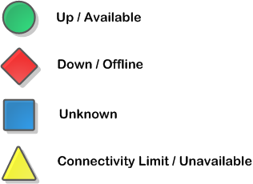
- Up / Available - Means the most recent monitor check was successful.
- Down / Offline - Means no response equal to the configured timeout period.
- Unknown - Typically means no monitor is assigned nor the monitor has yet to return a result.
- Connection Limit / Unavailable - Previously defined connection limit has been reached. In turn no traffic is sent.

INHERITANCE
The status of each monitor is inherited from its children.
If a node is marked offline, then the member is marked offline. As long as there are other members still online in the pool the Pool would still be marked as up.
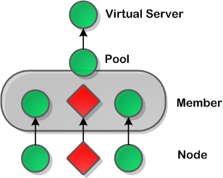
- What are the deployment modes of F5 LTM?
Routed mode
In route mode, the BIG-IP ASM system is in the routing path of the web servers, and all traffic to the server flows through the system.
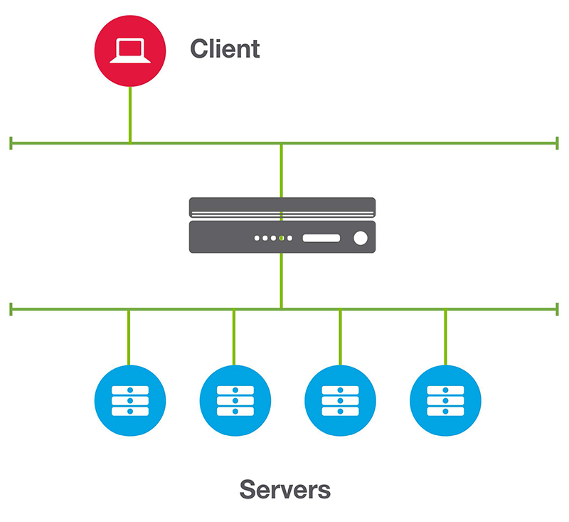
Figure 6.1 BIG-IP ASM routed mode deployment
- Servers detect the actual client IP address in the IP header for security and logging purposes. Since all communication traverses the BIG-IP system, there are no alternate, unprotected routes to the protected applications.
- The BIG-IP system must be configured to allow administrative and non-application traffic.
- Response traffic must be routed through the BIG-IP system. You usually accomplish this by setting the default gateway of the web server to the floating self-IP of the BIG-IP system.
One-armed mode
In one-armed mode, only application traffic flows through the BIG-IP ASM system, and the server-side connection uses a SNAT. The BIG-IP ASM appliance is logically in line with the web application traffic flow, but not physically in line with all traffic to and from the web servers.
Note: Requests and responses must go through the BIG-IP system. This means that if you do not use NAT on the source IP address of the client, the default gateway of the server needs to be the BIG-IP system. If you do use SNAT for all traffic from the client to an IP address of the BIG-IP system, all responses are sent back to the IP. To keep track of the original client IP address, you can enable the X-Forwarded-For feature of the HTTP profile. This adds the client IP address to the HTTP header that was sent to the web server.
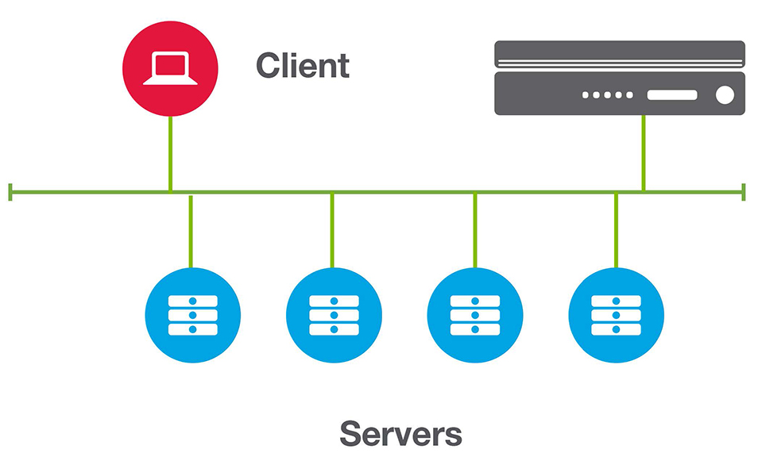
Figure 6.2 BIG-IP ASM single-arm deployment
- No changes to routing are required on the servers.
- Only application traffic is sent through the BIG-IP system, which reduces traffic traversing the device.
- Servers detect the IP address of the BIG-IP system in the TCP/IP header, which may complicate logging.
- There is more than one path to the protected application. You need additional security controls such as firewalls to ensure that malicious users do not access the application.
- What is SNAT in F5 LTM?
- A Secure Network Address Translation (SNAT) is an object that maps the source client IP address in a request to a translation address defined on the BIG-IP device. When the BIG-IP system receives a request from a client, and if the client IP address in the request is defined in the origin address list for the SNAT, the BIG-IP system translates the source IP address of the incoming packet to the SNAT address.
- A SNAT can be used by itself to pass traffic that is not destined for a virtual server. For example, you can use a SNAT object to pass certain traffic (such as DNS requests) from an internal network to an external network where your DNS server resides.
- A SNAT can also be used in conjunction with a virtual server and destination address of a NAT (displayed as NAT address in the Configuration utility) to translate the source IP address of an incoming connection. (With no SNAT configured, no source address translation takes place). In this case, the SNAT objects match traffic after the traffic has already matched a virtual server or NAT and, therefore, translates the source address upon egress to the server side, unless that traffic is already subjected to SNATs that are applied to the virtual server.
- How does SNAT work?
A SNAT works in the following manner:
- The BIG-IP system receives a request directly from a client or from virtual server traffic and verifies whether that source IP address is defined in the origin address list for the SNAT.
- If the client's IP address is defined in the origin address list for the SNAT, the BIG-IP system translates the source IP address to the translation address defined in the SNAT.
- The BIG-IP system then sends the client request to the pool member or other destination.
- What is rate shaping?
It protects networks and applications from traffic spikes, regulates abusive users, and prevents network attacks from overwhelming network resources. The BIG-IP® L7 Rate Shaping Module provides customized control to set application-based bandwidth limits and allowable bandwidth spikes.
- What are 3 key elements of iRule?
iRules are built using a TCL-based scripting language allowing arbitrary manipulation of traffic flowing through the BIG-IP, including real-time modification of defined data.

COMPONENTS OF AN IRULE
A typical iRule contains four main components.
These are :
rule NAME {
when EVENT {
if { conditional_statement } {
action_when_condition_true
}
}
}
- Name - The name a) Must begin with a letter b) contain no special characters or spaces. A naming best practice is to capitalize first letter of trailing words.
- Event - Events define multiple points during a client session, the iRule is then triggered when the specified event occurs. There are more than 50 types of Events such as HTTP_REQUEST, CLIENT_ACCEPTED etc.
- Conditional Statement - If a particular condition exists A condition is built based on relational/logical operators (explained further within the Rule Operators section). The following shows an example is the matching the string 'txt' at the end of an uri ; the condition would be if { [HTTP::uri] ends_with "txt" }.
- Perform an action - An action determines the response to a condition statement.
- What is the minimum RAM required to run BIG-IP Virtual Edition on ESXi?
The guest should have a minimum of 4 GB of RAM for the initial 2 virtual CPUs. For each additional CPU, you should add an additional 2 GB of RAM.
- What are key elements to be considered while selecting an F5 Load balancer (LTM)?
- Performance
- Scalability
- Visibility
- Security
- Manageability
- Flexibility
- What is a Static Load Balancing mode?
- Static load balancing modes do not use node performance information to make distribution decisions. For example, Round Robin is a static load balancing mode that load balances connections between available nodes without measuring the relative performance of those nodes.
- What is a Dynamic Load Balancing mode?
- Dynamic load balancing modes use node performance information to make load balancing decisions. For example, Least Connections is a dynamic load balancing mode that examines the ratio of open connections to nodes through Virtual Servers, and then sends the connection request to the node with the least number of concurrent connections.
- What is Server Load Balancing?
Server load balancing is the practice of dividing work evenly between various servers.
Server Load Balancing (SLB) provides network performance and content delivery by implementing a series of algorithms and priorities to respond to the specific requests made to the network. In simple terms, SLB distributes clients to a group of servers and ensures that clients are not sent to failed servers.
- What information needs to be provided to set up an appliance to do cookie load balancing?
You need the cookie name, cookie values, the VIP to bind to, and the groups to balance to
- What is Health Check in refer to load balancer?
The Health Check feature of the load balancer that allows you to set parameters to perform diagnostic observations on the performance of web servers and web server farms associated with each appliance. Health checking allows you to determine if a particular server or service is running or has failed. When a service fails health checks, the SLB algorithm will stop sending clients to that server until the service passes health checks again.
- When load balancing to a real server, which server will be accessed first?
- This depends on the load balancing method that you select. Here are a few examples:
- Least connections (lc) method “The real server with the lowest number of concurrent connections will receive the first connection. Round robin (rr) method “The real server with the lowest entry index will get the first connection. Shortest response (sr) “The load balancer or appliance will establish connections with each server and calculate the round trip time. The client connection will go to the real server with the lowest response time.
- What is the difference between a Persistent Cookie Policy and a QoS Cookie Policy in array network load balancer?
A Persistent Cookie policy selects a group based on the cookie name. A QoS Cookie policy selects a server group based on the cookie name and value assigned to that group.
- What is Global Server Load Balancing (GSLB)?
GSLB operates very similarly to SLB, but on a global scale. It allows you to load balance VIPs from different geographical locations as a single entity. This provides geographical site fault tolerance and scalability.
- Does the clustering needs to be turned on to use GSLB?
Yes, Clustering must be configured and turned on in order to use GSLB. Each proxy within the site (or cluster) must have the same configuration. Hence, each appliance can act as a DNS server if it becomes a master for the site. Each site will have a unique cluster/SLB/GSLB configuration, and you will use the gslb site overflow command to add the remote GSLB site to the local appliance.
- Which Load Balancing methods are supported with Array Network GSLB?

The Array appliance supports the following methods for GSLB:
- lc " Least connections sends clients to the site that has the least number of current connections.
- rr " Round robin simply sends client to each site in round robin succession.
- Overflow " Overflow allows requests to be sent to another (remote) site when the local site is 80% loaded.
- What is Reverse Proxy Cache?
Reverse Proxy Cache is a cache that is in front of the origin servers, hence the use of the term reverse in the name. If a client requests a cached object, the proxy will service the request from the cache instead of the origin server.
- Define LTM, GTM, APM, ASM.

- What are the LTM setup steps?
- How many characters does a base registration key have? 25
- What does Set up Utility include?

The Setup utility allows you to configure the following elements:
- License properties
- Module provisioning
- Device certificate
- Management interface settings such as the IP address, netmask, and default gateway
- Host IP address
- Time zone settings
- User account settings, such as the root and administrative passwords
- Support access
- SSH access
- Basic network configuration
- High-availability settings
- What are pool members?
A pool member is a logical object that represents a physical node (server), on the network. You then associate the pool with a virtual server on the BIG-IP system.
- What are the devices represented by IP addresses of pool members?
A pool member or node is a logical object that represents a physical node (and a service) on the network. When you add a virtual server to a pool, it becomes a pool member. A member or node includes the TCP port of the actual application that is receiving traffic.
- A full proof proxy maintains how many session tables? >> 2
- What is a proxy based design?
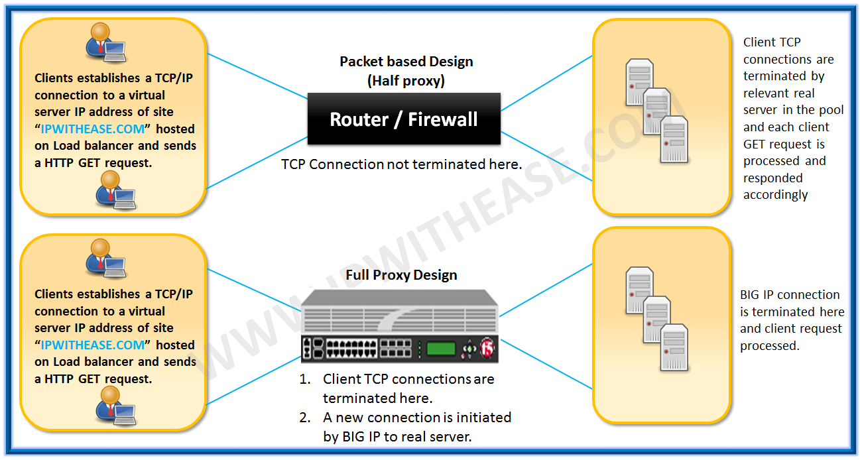
- F5 BIG IP platform has functionalities and features which tend to deliver higher performance and at the same time foster improved security. One such intelligent quality provided by these Application Delivery Devices is the Full-Proxy feature. Full-Proxy mode is an enhancement to packed based working of traditional Routers and Firewalls. Let’s further understand how Packet based design and Full Proxy differ from each other –
- Packet based solution is nothing but similar to our Router/Firewall which simply are located in middle of communication stream and forward packet to destination. Packet based designs have a single TCP/IP connection between client and server. With the help of Access-list or Firewall Rule one can block or allow traffic, which may not be the best of designs since we don’t have much view on the traffic passing through the device or can’t control the traffic traversing through the device. Let’s see how more intelligence is brought with introduction of F5 BigIP platforms. Full Proxy based design goes beyond the magnitude of just understating the traffic flow traversing through the device. Instead F5 box functions as endpoint and originator of protocols. With full proxy mode, we have 2 separate TCP/IP connections which means direct connection to server from client is not there and however, we have BIGIP in middle of client and server. Now we have 1* TCP/IP connection from Client to F5/BIG-IP (full proxy device) and 1* connection from F5/BIG-IP (full proxy device) to server, this means now you have better control on the traffic which is passing over the F5/BIG-IP. The proxy performs to role ie Firstly it acts as server to the client and secondly acts as client to the real server. Furthermore, each can have independent parameters applied, such as idle timeouts, buffers, MTU, window size and so on.
- Here are some benefits of using full proxy design: –
  - Inspection, manipulation and modification of application layer data
  - iRules (working above OSI Model layer four)
  - Advanced Persistence methods
  - SSL offload
  - TCP Optimizations
  - HTTP Compression, Caching and Pipelining
- What is an intelligent SNAT?
An intelligent SNAT, or iSNAT, is a type of SNAT that causes the BIG-IP system to select a translation address to map to an original client IP address based on any piece of packet data that you specify. This piece of data can be an original client IP address, but this is not required. Similar to a selective SNAT, an iSNAT maps an original client IP address to a SNAT pool, rather than to an individual translation address.
- How to monitor the number of concurrent connections going through the SNAT?
You can monitor the number of concurrent connections going through the SNAT by running the tmsh show /ltm snat command, or in the Configuration utility, choose one of the following methods:
- BIG-IP 11.1.0 and later versions:
Navigate to Statistics > Module Statistics > Local Traffic > Statistics Type (and click SNATs).
- BIG-IP 11.0.0 and earlier versions:
Navigate to Overview > Statistics > Local Traffic > Statistics Type (and click SNATs ).
- How is a member different than a node?
- What is a load balancing transaction?
- What is the primary reason for tracking and storing session data?
The primary reason for tracking and storing session data is to ensure that client requests are directed to the same pool member throughout the life of a session or during subsequent sessions.
- What is the Positive and Negative Security Model?
- What are HTTP Header Method?
- Which are the most important web server headers?
Here are the types of interesting HTTP headers that we will discuss:
- Server headers that protect against attacks
  - HTTP Strict Transport Security
  - Content Security Policy
  - Access-Control-Allow-Origin
  - X-FrameOptions
  - X-XSS-Protection
  - X-Content-Type-Options
- Server headers that leak information
  - Server
  - X-Powered-By
  - X-AspNet-Version
- What do Phase 1 and Phase 2 do?
- What 4 protocols is the SSL composed of?
http://techgenix.com/secure_socket_layer/
- What is the handshake protocol used for?
http://techgenix.com/secure_socket_layer/
- What is the Change Cipher Spec used for?
http://techgenix.com/secure_socket_layer/
- What is the Alert Protocol used for?
http://techgenix.com/secure_socket_layer/
- What is the Application data Protocol used for?
http://techgenix.com/secure_socket_layer/
- What Hash Algorithms are used in SSL “Client authentication?
http://techgenix.com/secure_socket_layer/
- Which two connection modes do IP Sec have?
- What is a tunnel mode?
- What is a transport mode?
- Which metrics can GTM use when making load balancing decisions for a client?
    - IP geolocation 2. Hop count 3. Round trip time
- Why do we need to use Layer 7 load balancing rather than Layer 3 and Layer 4?
- A layer 3 load-balancer takes routing decisions based on IP addressing alone (source & destination).
- A layer 4 load-balancer takes routing decision based on IPs and TCP or UDP ports. It has a packet view of the traffic exchanged between the client and a server which means it takes decisions packet by packet. This allows you to redirect traffic based on the ports in use (so port 80/443 for http/https, port 5060 for SIP etc) and so you can have multiple pools of VoiP and web servers and load balance specific flows across the pools. However a layer 4 load balancer cannot see the content of the data being passed through it or make routing decisions based on the content itself.
- Layer 7 load balancer operates at the high-level application layer, which deals with the actual content of each message. HTTP is the predominant Layer 7 protocol for website traffic on the Internet. Layer 7 load balancers route network traffic in a much more sophisticated way than Layer 4 load balancers, particularly applicable to TCP-based traffic such as HTTP. A Layer 7 load balancer terminates the network traffic and reads the message within. It can make a load-balancing decision based on the content of the message (the URL or cookie, for example). It then makes a new TCP connection to the selected upstream server (or reuses an existing one, by means of HTTP Keepalives) and writes the request to the server.
- Benefits of Layer 7 Load Balancing
Layer 7 load balancing is more CPU-intensive than packet-based Layer 4 load balancing, but rarely causes degraded performance on a modern server. Layer 7 load balancing enables the load balancer to make smarter load-balancing decisions, and to apply optimizations and changes to the content (such as compression and encryption). It uses buffering to offload slow connections from the upstream servers, which improves performance.
So in answer to your question, Layer 7 load balancers offer loads of benefits to network managers around how data is routed and managed. Since they can see the data within the network traffic, L7 load balancers can make routing decisions based on the application traffic status itself (eg http time-outs on one web server can trigger new requests to be delivered to another), and there is much more granular control.
Are Layer 7 Load balancers needed all the time? No not at all. Layer 4 Load balancing alone can be a really successful, but if you can justify them commercially and operationally, then L7 Load Balancers add a very powerful capability that can increase service availability and dramatically improve user experiences of those services.
- What is the difference between hardware load balancer and virtual load balancer?
- What is the difference between Local Traffic Manager and Global traffic Manager?
- What information is required to set up my appliance to do Cookie Load Balancing?
- When load balancing to a Real Server, which server will be accessed first?
- What is Dynamic Content and Static Content? Can the Array Appliance Cache Dynamic Content?
When a client requests a web page, a web server returns the requested content. If the content is retrieved from disk/memory and returned to the client without further processing, the content is said to be static. If the content is generated on-the-fly by the server (e.g., based on database data), it is referred to as dynamic content.
- What is Recursion Depth?
In a tree structure, it refers to the number of levels that can be traversed below the main or parent page. This is often used to specify how much of a web site (how many levels deep) to preload into the cache.
- How does cache decide what to cache?
The HTTP Cache-Control header determines the cacheability of the object and can also determine how long the object should be cached. The cache can be configured to override the cacheability of an object by specifying the hostname and a regular expression that matches within the URL of the object.
- What algorithms are used for Cache Content Replacement?
The Array (Hardware load balancer) Cache uses several algorithms for determining cache replacement behavior, depending on the context. In most cases, the Array will use LRU (Least Recently Used) to remove older content when space is needed.
- What is real clustering?
Real clustering allows all configurations from all appliances in the cluster to be synchronized. Of course, only global parameters such as the SLB configuration are synchronized. Local parameters such as interface IP addresses are not synchronized.
- What is virtual clustering and how does it work?
Virtual clustering provides fault tolerance for VIPs among cluster members. For example, if an appliance is handling traffic and it fails, another appliance in the cluster will take over traffic processing.
In a cluster of Array appliances(h/w load balancer), one appliance becomes Master for a particular VIP and handles all traffic related to that VIP. All others stay in Backup status. If the appliance containing the Master fails, one of the appliances in Backup status changes to Master status. Note: If multiple VIPs are configured, then Masters can be configured so that they are distributed among the appliances in the cluster, providing additional performance.
- What parameters need to be defined in the cluster configuration?
Cluster ID, VIP address, interface (Outside or Inside), priorities, and authorization method (password or none) must be defined. Preempt and mrthresh are optional.
- What is the purpose of content rewrite?
The Content Rewrite function allows CDN (Content Distribution Network) reference strings to be dynamically inserted into URLs that are embedded in web pages. With respect to one particular CDN, the term "linux" refers to the rewriting of embedded URLs to point to ubuntu-linux"s network.
- What is the use of extern and static?
- What is VLAN? How many bits are there is IPv4 protocol? What is RFC?
- Difference between router, hub and switch?
- Compare hash table and Binary balanced trees. List the scenarios when you will prefer hash table.
- What is SNAT and why is it required?
- Compare Global Traffic and SNAT.
- Compare Virtual Servers and SNAT.
- What is SNAT Automap?
- What is the SNAT Automap order of difference?
- Is Inline an alternative to SNAT and how?
- How to capture the source address with SNAT?
- Explain the benefits of using unique, custom profiles for virtual services.
- Explain a service issue where load balancer inspection or configuration alteration led to or implemented a solution.
- When would one recommend DSR vs full proxy?
- How can one implement L3 DSR?
- Do you encrypt traffic between the ADC and the service?
- Do you prefer Apache with mod_proxy, Nginx, HAProxy or other proxy software? Why?
- How do you automate service pools with proxies in use?
- How much TCP manipulation have you performed on the service and why?
- Explain the implementation, monitoring and adjusting QoS.
- Why should one use the first-hop redundancy protocols and why?
- IGRP would you like to discuss configuration for What?
- Can one use BGP as an IGRP?
- What is the difference between checked and unchecked exceptions?
- What is Connection Reaping in F5 LTM
--> LTM maintains server-side and client-side entries in the connection table.
--> Every connection to Virtual Server/NAT/SNAT the F5 LTM is going to allocate some memory/resources for the connection.
--> If the number of connection entries gets more then it consumes total system resources of F5.
--> TCP connections have connection open/close sequence so they can be removed automatically or manually from the connection table.
--> UDP connection does not have connection open/close sequence (Three-Way Handshake) such as TCP does.
--> F5 LTM depends upon idle timeouts for UDP Connections.
--> Connection reaping is the method of removing the connection entries in the connection table which were inactive for a long time.
--> Connection reaping allows the F5 LTM to use the system resources in an effective manner.
--> Connection reaping allows the F5 LTM to use the system resources only on active connections rather than inactive connections.
--> Idle time out value effects how F5 LTM is going to implement connection reaping.
--> SNAT AutoMap replaces the source IP of a server-side connection with its self IP/ Floating Self IP address.
--> Following are the idle timeouts that can be changeable on F5 LTM.
UDP Profile ---> 60 Seconds (Default)
TCP Profile ---> 300 Seconds (Default)
Fast L4 Profile --> 300 Seconds (Default)
Fast HTTP Profile --> 300 Seconds (Default)
SCTP Profile ---> 300 Seconds (Default)
--> The connection reaping feature allows the BIG-IP system to aggressively close the connections when the system memory utilization reaches the low-water mark, and stop establishing new connections when the system memory utilization reaches the high-water mark percentage.
--> The sweeper is the component within the Traffic Management Microkernel (TMM) core that watches for expired connection flows and responds to resource exhaustion by closing connection flows.
Low Water Mark: BIG IP LTM is going to remove the inactive connections.
High Water Mark: BIG IP LTM does not allow new connections to the system till the value reaches to lower water mark.
--> Adaptive reaping events are logged in the /var/log/ltm file.
--> The system comes with a default eviction policy named default-eviction-policy.
--> The default eviction policy uses values of 85% for low-water and 95% for high-water, and has the Bias Idle and Bias Oldest algorithms selected. You should not modify the values of a default policy.
--> If you want non-default values, you should create a custom eviction policy ( System --> Configuration --> Local Traffic --> Eviction Policy List).

- What is the difference between UCS and SCF file?
-> There are two different ways we can take the backup of F5 BIG IP device configuration:
1) UCS File
2) SCF File

1) UCS File
--> UCS stands for User Configuration Set.
--> UCS Archive saves all the configuration files in a tar file.
--> UCS Archive file contains following elements:

1) Configuration files
2) BIG IP License file
3) User Account Information
4) SSL Certificates with Private keys
5) DNS Zone Files
-->
1) GUI:
--> Navigate to System > Archives > Create
Name: Name of the Archive file
Encryption: If you want to put a password for the Archive
Private Keys: SSL Private Keys

2) CLI
--> # tmsh save /sys ucs [filename]
--> You can view all the UCS files in GUI, If they are stored in /Var/local/ucs directory.
--> To restore the UCS execute the following command from CLI:
🡪 # tmsh load /sys ucs [filename]

2) SCF File
--> SCF stands for Single Configuration file.
--> SCF contains all the different tmsh commands executed on the BIG IP System.
--> SCF file is used to replicate the configuration from hardware system to virtual system and vice-versa.
--> SCF File is also used to replicate the configuration across multiple F5 BIG IP Systems.
--> SCF File can only be created by using CLI of F5 System.
# tmsh save /sys config file [filename] no-passphrase
--> By default SCF files are stored in /Var/local/scf directory.
--> The main difference between scf file and UCS file is, The SCF file does not contain any license file which makes it as device independent.
--> UCS file contains license file which makes device dependent and used to backup and restores an existing F5 BIG IP System.

- Introduction to F5 Analytics
--> Analytics also known as Application Visibility and Reporting Module on BIG IP system.
--> Analytics used to analyze the performance of virtual servers configured on F5 BIG IP Systems.
--> Analytics can collect following information which helps the administrator to analyze the current performance and identify the issues in web applications configured on F5 Systems:

1) Server Latency
2) Client Latency
3) Server Throughput
4) Transactions per second
5) Number of sessions
--> Analytics also provides following information about the traffic passing to the Virtual Server such as,
1) Top Countries
2) Top URLS
3) Top Pool Members
4) IP Addresses
5) Top Response codes
--> Analytic information can be stored locally to BIG IP system or it can be stored on remote locations such as syslog server or SIEM Server.
--> Analytic can also be configured to send email alerts whenever a problem or particular limit is reached on Virtual Server.
--> Analytics is dependent on Adobe Flash Player.
--> There are two types of analytic profiles you can configure on BIG IP System:
1) HTTP Analytics Profile: To check web application statistics
2) TCP Analytics Profile: To check TCP statistics
--> By default, AVR ( Application Visibility Reporting) Module contains a default profile known as analytics.
--> Analytics profile works as parent profile for all the analytic profiles you create on BIG IP System.
- Introduction to vCMP in F5--> vCMP stands for Virtualized Clustered Multiprocessing.
--> vCMP is a hypervisor in F5 which allows you to divide one physical high powerful F5 device into multiple independent virtual F5 devices.
--> vCMP allocates CPU, memory, and storage for every logical or virtual BIG IP device.
--> We can create a number of instances of BIG IP system depend upon the configuration of the F5 hardware chasis.
--> vCMP uses built-in flexible resource allocation feature.
--> By using flexible resource allocation, We can allocate the separate size of resources to every BIG IP virtual instance according to the requirement.
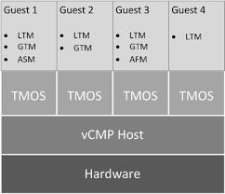

--> vCMP provides the resources to every virtual instance in the form of cores to it.
--> Each core contains a portion of CPU and memory assigned to it.
--> vCMP is not supported in all of the BIG IP devices.
--> vCMP is supported in some of VIPRION chassis and BIG IP Devices such as,

i) VIPRION B2100, B4200, B4300, B4340N
ii) BIG IP 5200v, 7200v,10200v

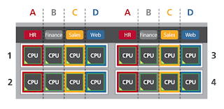
--> With vCMP we have the following components,

i) vCMP host
--> This is the hypervisor which allows you to create and configure BIG IP Instances.
--> This Instances are known as vCMP guests.
--> For every guest, vCMP host allocates CPU and memory to it.

ii) vCMP Guest
--> vCMP Guest is the BIG IP instance which is created on vCMP host.
--> Each and every vCMP Guest is allocated BIG IP Modules such as LTM, GTM, ASM and APM to process the traffic.
--> Every Guest contains its own self IP Address, Management IP Address, and list of Virtual Servers.
--> Every Guest act as separate BIG IP device without having the knowledge of other BIG IP instances are present on vCMP host.
--> Each Guest can be divided by using Route domains and Partitions.
--> Each Guest can have different BIG IP version and different modules compared to other Guests in vCMP host.

iii) Virtual Disk
--> Virtual Disk is the storage area for the vCMP guest on the vCMP host.
--> Each Virtual Disk is configured as an image file with .img extension.
--> If vCMP Guest is allocated in two slots of vCMP host then the system creates and assigns two virtual disks to the guest.

iv) Cores
--> A Core is the Portion of CPU and system memory allocated to a guest.
--> The Amount of CPU and System memory that core contains depends upon the hardware platform.
--> CPU's in the core remain idle if the Core is not assigned to any host.

Note: There are two types of Administrators would come into picture when we use vCMP.

i) vCMP host Admin:
--> used for creating guests and assigning the resources to the guests.

ii) vCMP guest Admin:
--> used for assigning and provisioning the BIG IP modules within the guest.
- What is SSL Bridging in F5 LTM?
SSL Bridging
--> Client SSL Profile only encrypts the traffic between Client and F5 LTM.
--> It does not encrypt the traffic between F5 LTM and Real Server.
--> But if there is a requirement that the traffic between LTM and the real server also need to be encrypted then in that case we use SSL Bridging.
--> SSL Bridging or SSL Termination allows the traffic between LTM and Real Server to be encrypted before sending.
--> In order to enable SSL Bridging, we need to create SSL Server Profile and assign it to the Virtual Server in addition to Client SSL Profile.
--> Once you apply Client SSL and Server SSL Profile to the Virtual Server, F5 LTM Creates two encrypted sessions:

i) Encrypted Session between Client and F5 LTM. (Client SSL Profile)
ii) Encrypted Session between F5 LTM and Real Servers (Server SSL Profile)
--> We can use different Certificates for different Sessions in F5 LTM.
--> For example, We can use SSL Certificate with higher key length on Client SSL Profile and SSL Certificate with lower key length on Server SSL Profile.
--> SSL Bridging Concept needs to be applied on Correct Pool on F5 LTM. (Only For pool with HTTPS traffic)
- Types of Monitors used in F5 LTM?
Simple Monitoring
--> A Simple Monitoring just checks whether a host is reachable or offline.
--> No Intelligence present.
--> Following are the monitors used in simple monitoring,

1) Gateway ICMP
2) ICMP
3) TCP_ECHO

Active Monitoring
--> In Active Monitoring, BIG IP sends some type of application traffic and waits for a response from the node or pool member.
--> Uses Intelligence.
--> This can be done by using send and receive string configured under the monitor.
--> F5 LTM makes node or pool member offline, if it does not receive the response or if the response is not matching the specific receive string.
--> HTTP and FTP are the monitors used in Active Monitoring.
--> Active Monitoring creates additional traffic and uses additional resources on F5 LTM.
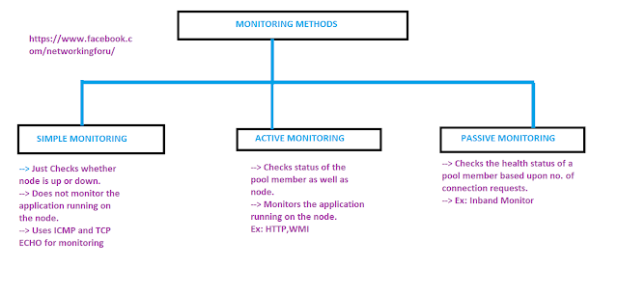
Passive Monitoring
--> In Passive Monitoring, BIG IP does not sends any type of application traffic to know node or pool member is offline or not.
--> Passive Monitoring is also known as Inband Monitoring.
--> In Passive Monitoring, BIG IP LTM monitors the traffic is going to/from pool member.
--> If the pool member does not respond to new connections or existing connections properly then f5 ltm makes pool member as offline.
--> The main advantage of Passive Monitoring is, it does not create any additional traffic to find out the pool member is offline or online.
--> Does not consume more resources on F5 LTM.
--> Passive Monitoring does not check for specific resources which makes f5 ltm slow to identify pool member or node is offline.
--> Inband monitor is the only monitor used in Passive Monitoring.
--> Passive Monitor works depends on the client traffic from F5 LTM to Pool Member.
- What is the difference between positive and negative security model?
--> Selecting the security model depends upon the type of the network and content you are going to secure.
--> There are basically two security models are used in the network.

1) Positive Security Model
--> A Positive Security model is also known as whitelist model.
--> A Positive Security model works by denying everything and allow only the things which are required in the network.
--> All the firewalls in the network works on this model.
--> The main advantage of implementing a positive security model in the network is that zero-day attacks can be prevented.
--> Positive Security Model leads to more false positives, as it blocks everything related to an application until you specify it.
--> If an application changes or modifies its behavior we need to create a new policy in order the application to work.
--> Positive Security model is recommended for securing web applications.
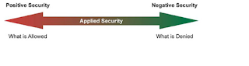

2) Negative Security Model
--> A Negative Security model is also known as Blacklist model.
--> A Negative Security model works by allowing everything and denies only the things which are required in the network.
--> Anti-Virus and IPS/IDS in the network works on this model.
--> The main advantage of implementing negative security model in the network is it can be deployed rapidly.
--> Negative Security Model does not lead to more false positives, as it allows everything related to an application and denies the things which are specified manually.
--> Negative Security Model cannot prevent zero-day attacks because of its behavior.
--> Negative security model is recommended for anti-spam and antivirus.
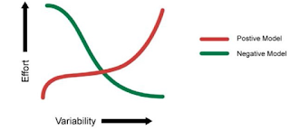

--> In order to find which model is suited for your organization there are a number of factors we need to consider,

i) Number of objects
ii) Number of content types
iii) Content Changes
--> For example, if a website is having fewer objects ( ex:50 objects) and having only pictures and texts then it is recommended to use the positive security model.
--> For example, if a website is having more objects ( ex:500 objects) and content changes every day then it is recommended to use the negative security model.
- What is the use of Port Lock down Setting in F5 LTM?
- --> Port Lockdown security feature allows only specific protocols and services required on the self IP address in F5 LTM.
--> The port lockdown feature allows you to secure the F5 LTM from unwanted connection attempts by controlling the services or ports allowed on each self IP address.
--> Port Lockdown setting only filters traffic on the self IP address and it does not have any effect on management IP Address.
--> ICMP Traffic is by default allowed with all the Port Lockdown settings configured on the self IP address.
--> There are some specific services which are allowed even if it is not listed in a port lockdown setting such as,

i) TCP mirroring ports: TCP Ports from 1029 to 1155
ii) Centralized Management Infrastructure port: TCP Port 4353
iii) ICMP
--> There are four port lockdown settings available in F5 LTM.
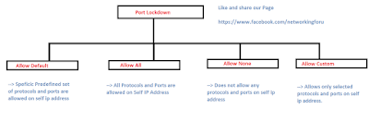
i) Allow Default
--> This setting allows access for a list of predefined protocols that are needed in order BIG IP LTM to work.
--> These are the following services allowed in the Allow Default Setting,

IGMP( Layer 2 Multicasting)
OSPF( Routing Protocol)
PIM ( Layer 3 Multicasting)
TCP 4353 (iQuery)
UDP 4353 (iQuery)
TCP 443 ( HTTPS)
TCP 161 (SNMP)
UDP 161 (SNMP)
TCP 22 (SSH)
TCP 53 (DNS)
UDP 53 (DNS)
UDP 520 (RIP)
UDP 1026
--> If you want to check the list of protocols and ports that are allowed on Allow Default Setting using CLI command,
#tmsh list net self-allow

ii) Allow All
--> This Setting allows all Protocols and ports from which connections are allowed to the self IP address on F5 LTM.

iii) Allow None
--> This Setting does not allow any Protocols and ports from which connections are allowed to the self IP address on F5 LTM.
--> But it allows ICMP protocol to the self IP address on F5 LTM.
--> This is the default setting for the port lockdown on self IP address.

iv) Allow Custom
--> This Setting allows specific protocols and ports from which connections are allowed to the self IP address on F5 LTM.
--> It allows ICMP protocol even if it is not listed in the setting to the self IP address on F5 LTM.

To Change LockDown Settings for a self IP address,
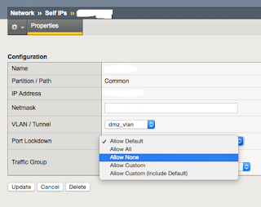

i) Login into Web GUI of F5 LTM.
ii) Navigate to Network > Self IP Address.
iii) Select the Self IP Address for which you want to modify the port lockdown setting.
iv) From the Port Lockdown setting box select the setting you want to change and click on update.
Note: For Improved security, F5 recommends allows only specific ports and protocols required for connection for a self IP address.

- What is the use of TCPDUMP in F5 LTM?
- --> TCPDUMP function on F5 LTM is used for capturing the packets that are sent/received on a particular interface from the command line.
--> TCPDUMP is having the same functionality as Wireshark tool.
--> TCPDUMP tool is mainly used on F5 LTM for troubleshooting and security posture of the network.
--> By default when you run TCPDUMP tool on F5 LTM, it tries to do DNS resolution for the IP Addresses which consumes so much of time.
--> It is recommended to disable TCPDUMP tool before running the capture on the interface of F5 LTM.
--> In order to disable TCPDUMP tool on F5 LTM, execute the following command on F5 LTM from CLI without brackets( tcpdump -ni 1.1).
--> These are the following tcpdump commands which mostly used for troubleshooting purposes,

1) For capturing the packets on a particular interface: tcpdump -ni 1.1 or tcpdump -ni Internal
2) To Save the TCPDUMP output in binary format: tcpdump -w <filename> ( Ex: tcpdump -w packet1.bin)
3) To Save the TCPDUMP output in text format: tcpdump ><filename> (Ex: tcpdump >packet1.txt)

Note: TCPDUMP does not show any data on the screen when you are saving the packets in binary or text format. In order to stop the capture, press ctrl+c from the keyboard.

4) To read the data from TCPDUMP file on F5 LTM: tcpdump -r <filename> (Ex: tcpdump -r packet1.bin)
5) To capture the packets with limited size: tcpdump -s2000 -ni Internal

F5 SUPPORT
--> Using tcpdump utility we can also capture internal TMM information of F5 LTM.
--> This TMM information is useful when you need to open a case with F5 Support.
--> To capture Internal TMM information on F5 LTM, use the following command: tcpdump -i <interface>:<noise amplitude>
-->The noise amplitude specifies the level of TMM details included in the packet capture. The following noise levels may be captured:

n: Low details
nn: Low and medium details
nnn: Low, medium, and high details
--> For more information about what is low, medium and high details, click on the below link

https://support.f5.com/csp/article/K13637

FILTERING the packets in tcpdump Packet Capture
--> Filters allow you to limit the packet capture output related to specific IP Address, ports, and TCP flags.
--> TCPDUMP Filtering in F5 LTM works similar to Wireshark utility.
--> These are the following tcpdump commands which mostly used for filtering purposes,

1) For capturing the packets from or to a particular address: tcpdump host 192.168.1.50
2) For capturing the packets from a particular address : tcpdump src host 192.168.1.51
3) For capturing the packets to a particular address : tcpdump dst host 192.168.1.100
4) For capturing the packets either from source or destination port : tcpdump port 80
5) For capturing the packets which contain source port 80: tcpdump src port 80
6) For capturing the packets which contain destination port 80: tcpdump dst port 80
7) For Capturing the TCP flags for example SYN flag: tcpdump ‘tcp[tcpflags] & (tcp-syn) != 0’
8) For Capturing the TCP flags for example ACK flag: tcpdump ‘tcp[tcpflags] & (tcp-ack) != 0’

Combining the filters using AND operator

1) If you want to capture the traffic starting from client 192.168.1.1 going to virtual server 172.16.1.100 : tcpdump src host 192.168.1.1 and dst host 172.16.1.100

2) If you want to capture the traffic starting from client 192.168.1.1 going to virtual server 172.16.1.100 only on destination port 80: tcpdump src host 192.168.1.1 and dst host 172.16.1.100 and dst port 80
- Understanding Status of Virtual Server in F5 LTM
Enabled:
--> Virtual Server is working and able to forward the traffic to the servers.
--> Monitors associated with virtual servers are working.
--> Shows Green circle in the virtual server status icon.

Offline
--> The Virtual server is not working and unable to forward the traffic to the servers.
--> Monitors associated with virtual servers are not working.
--> Shows Red Diamond icon in the virtual server status.

Currently Unavailable
--> The Virtual server is working but unable to forward the traffic to the servers.
--> Monitors associated with virtual servers are working.
--> limiting the connection rate has been set up and the virtual server has no more memory to accept the connections for the virtual server.
--> Shows Yellow Triangle icon in the virtual server status.

Unknown
--> Virtual Server is working and able to forward the traffic to the servers.
--> Monitors are not configured for the virtual server.
--> The traffic received on the virtual server will be forwarded to pool members even they are not working.
--> Shows Blue Square icon in the virtual server status.
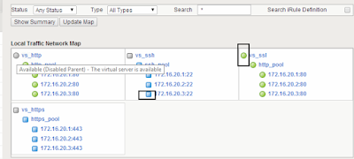
Disabled
--> The Virtual server is not working and unable to forward the traffic to the servers.
--> Network Admin has disabled the virtual server manually.
--> If the monitors configured are working properly then shows Black circle icon in the virtual server status.
--> If the monitors configured are not working then shows Black Diamond icon in the virtual server status.
- How to troubleshoot the issues related to Virtual Server in F5 LTM
Self IP Address
--> Check the packets are hitting the self IP address of F5 Load Balancer.
--> Check Portlock down settings on the self IP address.
--> By using Port Lockdown we can control what types of connections will be allowed to the self IP based on protocol and port.
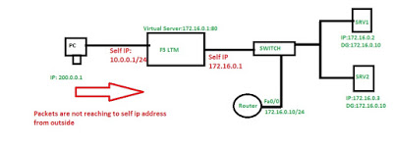

Connection Table
--> Check the packet from the source has been arrived in connection table or not.
--> Connection table stores all the connections going via F5 LTM.
--> Server Side and Client Side connections are stored.
--> Every Connection in connection table uses the resources on F5 LTM.
--> Inactive connections can be removed by setting connection timeout which saves resources on F5 LTM.
--> If you want to check connection table on F5 LTM using CLI command: tmsh show sys connection.

Packet Filter
--> If the packet is present in the connection table then check whether any packet filter rule is configured on the interface.
--> Packet filter improves the network security which tells BIG IP LTM interface to accept or drop the
Connection.
--> Packet Filter can drop or allow the connection on interface based upon,

i) Source IP Address
ii) Destination IP Address
iii) Destination Port
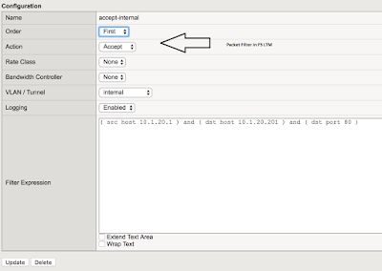

Virtual Server
--> Check whether the virtual server is configured or not for the given destination ip address and port number.
--> If more than one virtual server is configured on F5 LTM then check virtual server precedence.
--> The order of Virtual Server Precedence as follows,

i) IP: Port
ii) IP: Any
iii) Network: Port
iv) Network: Any
v) Any: Port
vi) Any: Any
--> Check my following post on virtual server precedence: http://networkingmaterials.blogspot.com/2017/10/what-is-virtual-server-precedence.html
--> Check Pool status associated with F5 Virtual Server.
--> By default BIG IP LTM work as default deny device if no virtual servers or listeners are configured then F5 LTM is going to drop traffic.

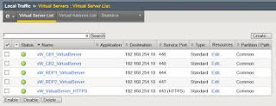

SNAT
--> Check SNAT or NAT are working properly if they configured.
--> SNAT or NAT is used to resolve asymmetric routing issues with F5 LTM.
--> Check my following post on SNAT and NAT:

http://networkingmaterials.blogspot.com/2018/09/where-to-use-snat-in-f5-ltm.html
http://networkingmaterials.blogspot.com/2018/09/what-is-diffrerence-between-nat-and.html

Connectivity with Backend Servers
--> We can use multiple tools to find out the connectivity issues between the backend servers with F5 LTM.
--> If there is any PC on the server network then you can check the connectivity between PC and the server which you are facing the issue.
--> If it is responding then try to ping the server from F5 LTM.
--> If there is IP Connectivity we can use CURL command on F5 LTM to see whether F5 LTM can connect to the website on the server or FTP on the server for the traffic.
--> You can also use Wireshark or logs to find out the issue.

- Where to Use SNAT in F5 LTM?

1) When the Internal Node Servers default gateway is not BIG IP LTM
--> It is not always possible to configure BIG IP LTM as internal node servers default gateway.
--> Internal Node Servers default gateway can be a router or layer 3 switch.
--> The problem with this type of setup is,it can prevent the response packet to go back to the client as BIG IP LTM is not a default gateway.
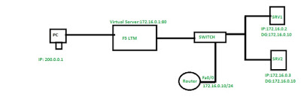

--> In the above scenario, the router is acting as the default gateway for the internal nodes.

1) The client sends the request packet to F5 Virtual Server IP Address.
2) F5 BIG IP LTM Changes the destination IP address from the virtual server IP address to pool member IP address selected based upon load balancing algorithm.
3) Pool member receives the request packet from F5 BIG IP LTM and sends the response packet to the router as it is acting as the default gateway.
4) The client is going to reject the packet as it does not have the connection with pool member.
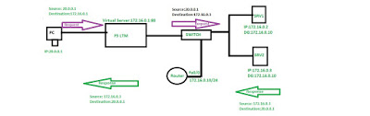
--> With SNAT
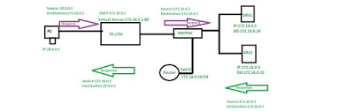

1) The client sends the request packet to F5 Virtual Server IP Address.
2) F5 BIG IP LTM Changes the source IP address to SNAT IP Address and the destination IP address from the virtual server IP address to pool member IP address selected based upon load balancing algorithm.
3) Pool member receives the request packet from F5 BIG IP LTM and sends the response packet to the F5 LTM as both are in the same network.
4) The client is going to receive the packet from F5 BIG IP LTM.

2) Client and Servers in the same network
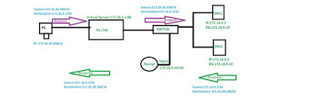

--> If both the server and client belongs to the same network then the traffic directly goes without consulting F5 BIG IP System.
--> With SNAT, we can change the source IP address that allows the server response to go via F5 BIG IP LTM.

1) The client sends the request packet to F5 Virtual Server IP Address.
2) F5 BIG IP LTM Changes the destination IP address from the virtual server IP address to pool member IP address selected based upon load balancing algorithm.
3) Pool member receives the request packet from F5 BIG IP LTM and sends the response packet directly to the client as both are on the same network.
4) The client is going to reject the packet as it does not have the connection with pool member.

With SNAT
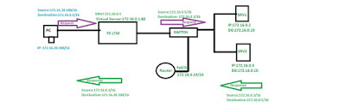
1) The client sends the request packet to F5 Virtual Server IP Address.
2) F5 BIG IP LTM Changes the source IP address to SNAT IP Address and the destination IP address from the virtual server IP address to pool member IP address selected based upon load balancing algorithm.
3) Pool member receives the request packet from F5 BIG IP LTM and sends the response packet to the F5 LTM as both are in the same network.
4) The client is going to receive the packet from F5 BIG IP LTM.
3) Internal Server needs to send the traffic to the Internet
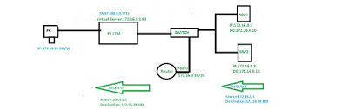

--> Internal server are having private IP address sometimes need to send traffic to the Internet.
--> SNAT allows the internal server private IP address to be changed to the routable public IP address.

